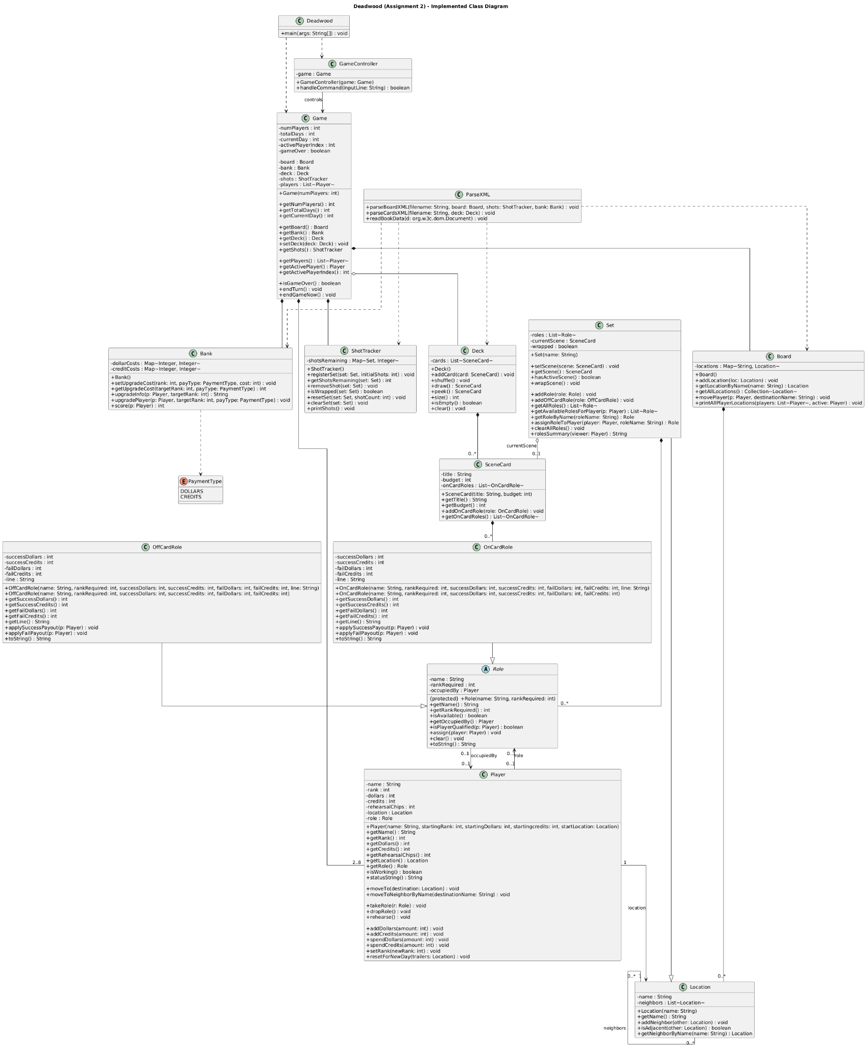
Design Explanation:
This design separates the game into clear responsibilities. Game serves as the primary model that holds the core state (players, day/turn tracking, and links to Board, Deck, Bank, and ShotTracker). GameController offers the command-based interface and assigns actions to the model rather than incorporating state changes directly within the UI loop. This keeps the logic testable and prevents user input code from being mixed with the game rules.
The world is represented by Board, which manages and looks up Location objects by name and supports player movement. Set extends Location to reuse navigation behavior while adding set-specific concerns like roles and the active SceneCard. Roles use an abstract Role base class that contains shared occupancy logic. There are two concrete subclasses, OnCardRole and OffCardRole. They differ only in how they handle payouts. This setup keeps the role logic consistent and prevents duplication. Additionally, ParseXML acts as an importer. It creates the Board, Deck, and initial ShotTracker/Bank state from XML. This design allows the rest of the program to stay independent of the file parsing details.

